OpenWRT Router Setup on VirtualBox

This guide will walk you through the steps of adding an OpenWRT router to VirtualBox as a virtual machine so that you can test your routing protocol! :)

# Prerequisites

Download and install the latest version of VirtualBox [here](https://www.virtualbox.org/wiki/Downloads)

# OpenWRT Setup

## Get OpenWRT image

You will need a x86 64bit version of OpenWRT.

Go to this [link](https://downloads.openwrt.org/releases/)

1. Choose the latest release version
2. Click target
3. Click x84
4. Click 64

From this menu you will need to choose the file:

**combined-ext4.img.gz**

Click [here](https://openwrt.org/docs/guide-user/virtualization/virtualbox-vm) for more information about the difference between the types of images.

Uncompress the .img file with the linux command:

gzip -d openwrt-*x86-64-combined*.img.gz

If successful, you should have the raw image file, **openwrt-x86-64-combined-ext4.img**

**NOTE:** the file names might differ slightly depending on the release, so replace the

“openwrt-*x86-64-combined*.img.gz” with your file name if needed.

## Convert the image to a VirtualBox drive

In the terminal, change your directory to the location of your raw image folder using the cd command.

To create the virtual drive called “openwrt.vdi”, run the following command:

VBoxManage convertfromraw --format VDI openwrt-*x86-64-combined*.img openwrt.vdi

**If you get an error with the Error code “VERR_VD_INVALID_SIZE” and you cannot create the image, you will need to run the following commands to pad the image:**

dd if=openwrt-x86-64-combined-ext4.img of=openwrt.img bs=128000 conv=sync

VBoxManage convertfromraw --format VDI openwrt.img openwrt.vdi.

## Create the OpenWRT Virtual Machine

Start VirtualBox and click New add a new virtual machine. You should input values so that the window that pops up looks like this.

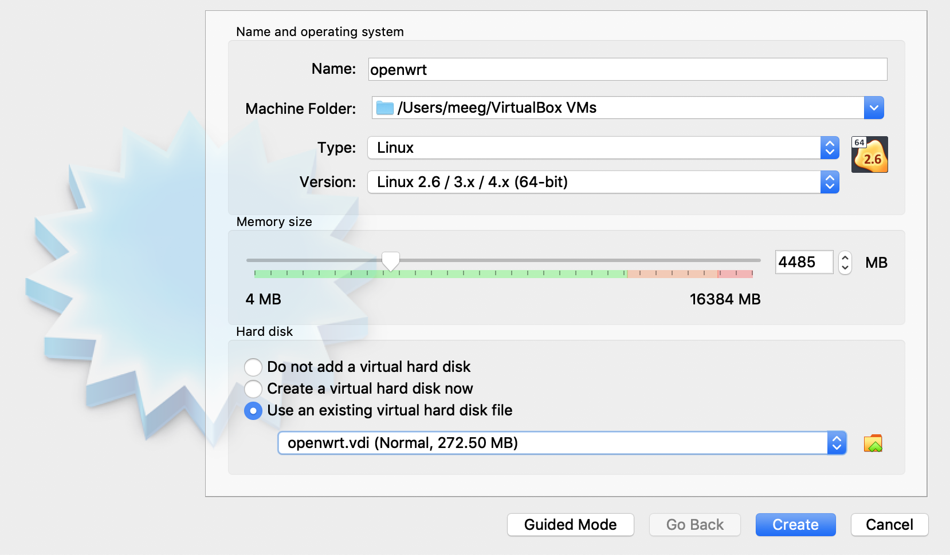

The Machine Folder will vary of course, but make sure you place the image in a permanent place before linking with VirtualBox. It is not required, but helps to mitigate future issues

Press the Create button!

## Edit VirtualBox Settings

Follow the [VM Setup](https://openwrt.org/docs/guide-user/virtualization/virtualbox-vm)  Guide.

When you are finished editing the settings of your router’s virtual machine, they should appear to the right of your machine like this:

